**Iteration 0**

**Team roles**

**Project owner:**

**Jincheng Li:** [**lijincheng0903@tamu.edu**](mailto:lijincheng0903@tamu.edu)

**Scrum master:**

**Xiaomu Dong:** [**xid2019@tamu.edu**](mailto:xid2019@tamu.edu)

**Team member:**

**Ruxin Zhang:** [**ruxinzhang@tamu.edu**](mailto:ruxinzhang@tamu.edu)

**Ruichao Wang:** [**chaochaoddln@tamu.edu**](mailto:chaochaoddln@tamu.edu)

**Wenlin Li:** [**wenlin_li@tamu.edu**](mailto:wenlin_li@tamu.edu)

**Jia Fu:** [**fujia_tamu_2020@tamu.edu**](mailto:fujia_tamu_2020@tamu.edu)

**Customer meeting date/time/place**

Customer meeting with Dr. Walker, every Thurs 10:00 am - 10:15 am on Zoom.

**Summary**

The primary aim of this project is to create animations to be used in StepStone, a

learning environment currently used by the PEER Program in Texas A&M’s College of Veterinary Medicine to aid in providing TEKS curriculum content for use by 6 th - 8 th grade teachers and students. The Peer homepage further links to the One Health curriculum, named after the biological reality humans and animals share the same biology and many similar diseases. The curriculum currently offers multiple modules, and past projects involved the Cell Biology Module , such as creating games and animations so that the learning experience would be more interactive and engaging for students. All of the animations will ultimately be integrated into the already existing StepStone module to add onto or improve the current slides.

**User stories**

User story 1 - slide 4

Feature: Feedback animation for revealing the solution in cell theory section

As a user, when I click on the cover on the answer, I want to see the answer under the cover.

User story 2 - slide 8

Feature: Feedback animation for the fill in the blanks question in the cell theory section.

As a user, when I drag the word to the blank, I want the word to stay on the blank if the word is correct, and I want the word to go back to the answer box if it is not correct.

User story 3 - slide 12

Feature: Feedback animation for revealing the answer in the table in the cell types section.

As a user, when I click on one row of the table, I want to see the content in that row of the table.

User story 4 - slide 14

Feature: Feedback animation for revealing the definition in the cell types section.

As a user, when I click on the slide, I want to see the definition of the organelles of eukaryotic cells.

**User interface**

1. UI sketch for user story 1 - slide 4:

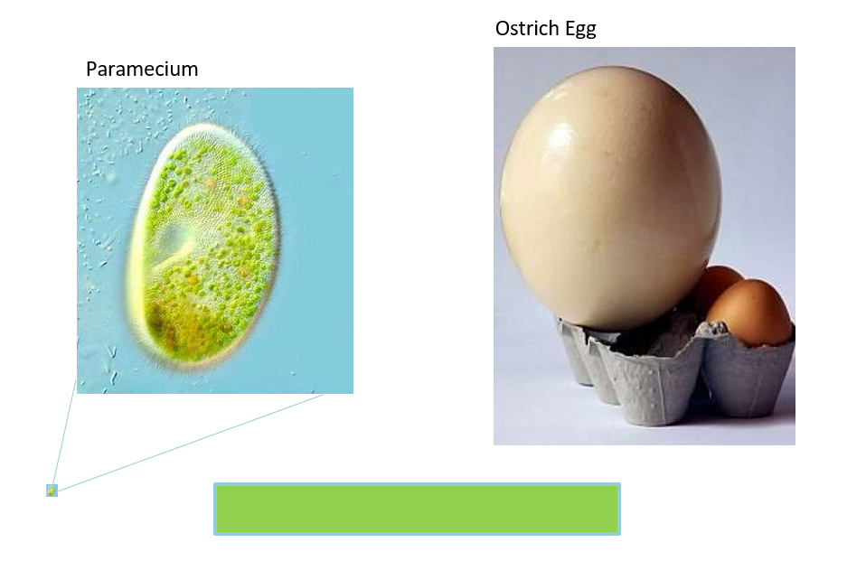

Storyboard for user story 1 - slide 4:

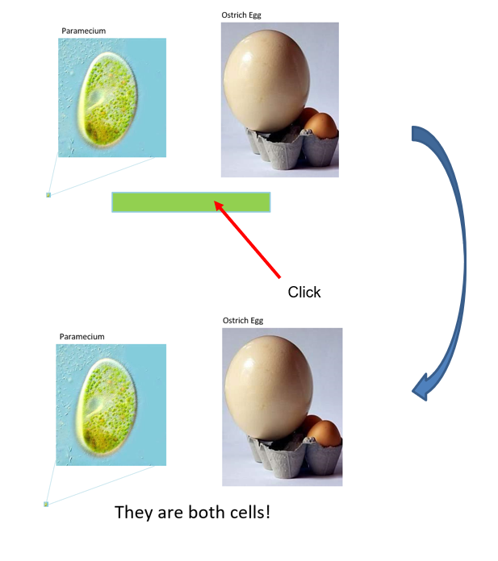

1. UI sketch for user story 2 - slide 8:

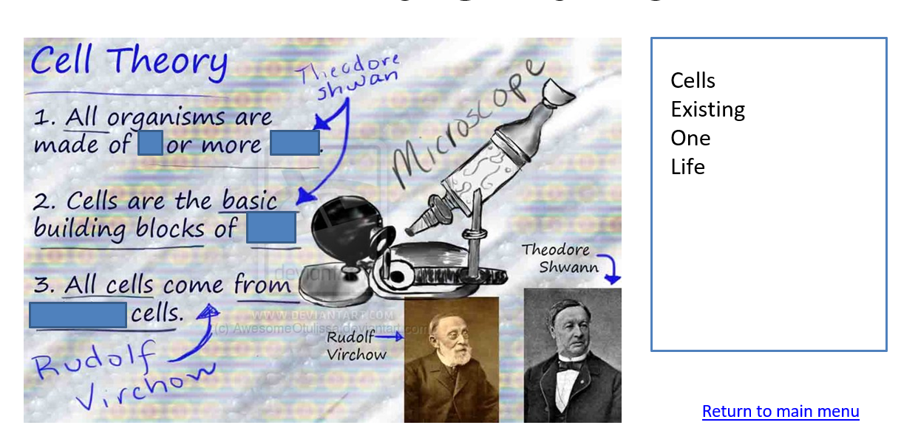

Storyboard for user story 2 - slide 8:

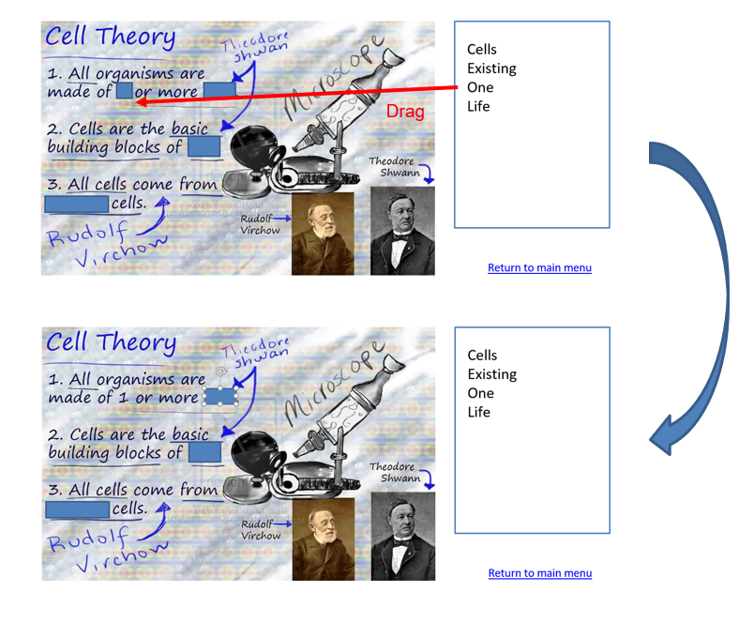

1. UI sketch for user story 3 - slide 12:

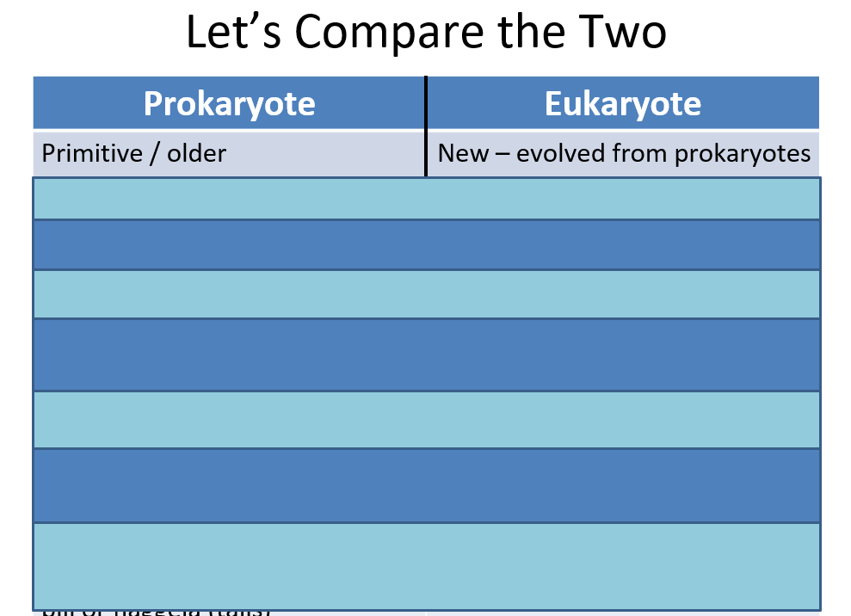

Storyboard for user story 3 - slide 12:

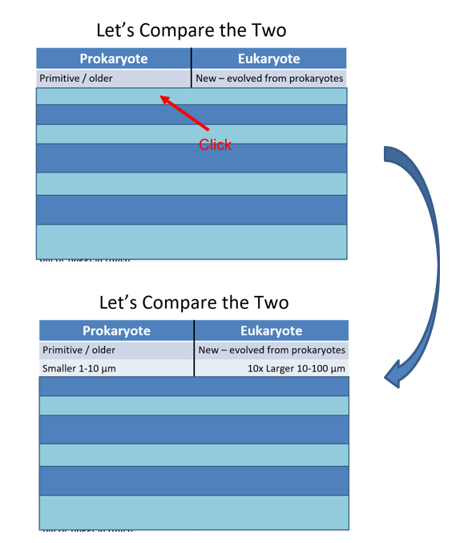

1. UI sketch for user story 4 - slide 14:

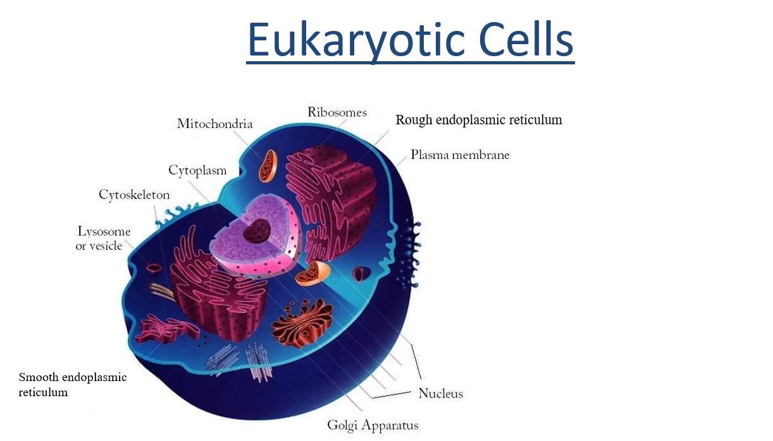

Storyboard for user story 4 - slide 14:

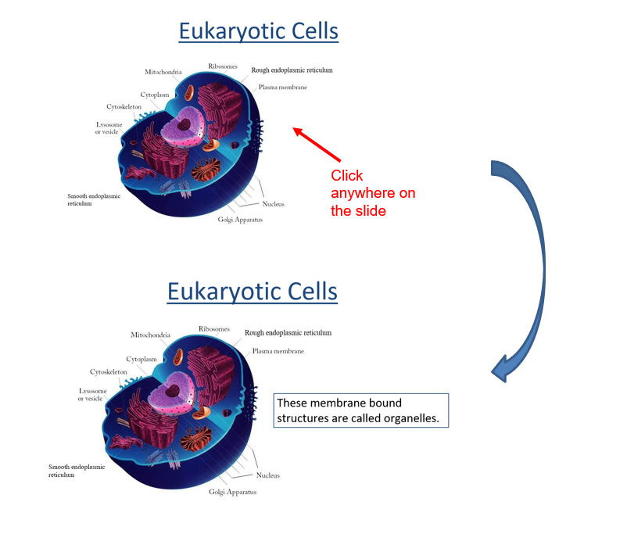

**Pivotal tracker: 回头再搞**

**GitHub**

**Slack channel: Completed**

**Legacy projects: write a one-page document discussing your overall strategy for learning/improving the prior code.**

The legacy project we are referring to is the Animations in Stress Learning Content developed by the team *HalfGrads* in the previous semester. Their [animation repository](https://github.com/cwrothrock/Animations-in-Stress-Learning-Content) contains animations of different modules, including drag and drop, drag and connect, Hangman, ordering images, weighted scale and word selections. In each module, they include different slides that utilizes those animations. After our team thoroughly investigated their legacy code, we decided to implement our cell essential knowledge interaction slides in a similar, module like fashion. We plan to reconstruct the JavaScript interaction and web design for a better clarity and user interaction.

In the legacy code repository, they set up a jQuery application with Stepstone and implement various user interactions with HTML, CSS, JavaScript, and jQuery. To resize the web application for different screen sizes, they included an add-on JavaScript named ‘iframeResizer.contentWindow.min.js’ from the open source [iframeResizer](http://davidjbradshaw.github.io/iframe-resizer/) tool. Moreover, the legacy project team also includes their own CSS style sheet for a better visual representation.

The difference between the legacy project and ours is the contents. While the legacy project focuses mainly on the biology behind stress, such as the nerve system, our team will be working on the biology cell knowledge slides. The slides we’ll be working on focus primarily on the composition, structures, and theoretical knowledge of cell biology. Dr. Walker will be assigning us the slides and we’ll compose the user story corresponding to those slides. Overall, the legacy codes will serve us as an example of different animations and user interactions, but our team will work on new modules with different contents.